# Educational Organisation Using ServiceNow

### ****TEAM ID:**** NM2025TMID18283

### ****TEAM MEMBERS:****

### Team Leader: Yamuna.A

### Team Member: Rithika.B

### Team Member: Saranya.R

### Team Member: Pooja.K

## PROBLEM STATEMENT:

In many educational institutions, student admissions, records, and academic progress are still managed manually. This traditional approach creates several issues such as delays in the admission process, errors in data handling, and difficulties in generating unique admission numbers. The absence of a centralized system leads to scattered student and parent information, making it hard to access and maintain. Furthermore, tracking student performance and progress becomes inefficient, while the lack of automation increases staff workload and reduces accuracy. To address these challenges, there is a need for an automated system that streamlines admissions, ensures data consistency, and simplifies overall management.

**OBJECTIVE:**

The objectives of the project **“Educational Organisation Using ServiceNow”** are:

* To automate the **student admission process** and reduce manual errors.
* To generate and maintain **unique admission numbers** using number maintenance.
* To create a **centralized system** for storing student and parent details.
* To design **user-friendly forms and layouts** for easy data entry and management.
* To implement **process flows** for tracking admission stages effectively.
* To add **client scripts** (e.g., Pincode Update) for dynamic updates and accuracy.
* To provide a system that improves **efficiency, accuracy, and transparency** in educational management.

**SKILLS:**

During the development of the project **“Educational Organisation Using ServiceNow”**, the following skills were applied and enhanced:

* **ServiceNow Development Skills** – Creating update sets, tables, forms, workflows, and client scripts.
* **Form Design & Layout Skills** – Customizing form structures for clear and user-friendly data entry.
* **Workflow and Process Automation** – Designing process flows for admissions and automating record management.
* **Scripting Skills** – Writing client scripts such as Pincode Update for dynamic form behavior.
* **Database Management** – Creating and managing custom tables for student, admission, and progress records.
* **Problem-Solving** – Identifying challenges in manual systems and designing automated solutions.
* **Team Collaboration** – Working as a team to design, configure, and test the system step by step.­­­­­­­­­­

**TASK INITIATION**

**Milestone 1: Update Set**

**Activity 1: Create Update Set**

**Steps:**

1. Navigate to **All → Local Update Sets**.
2. Click on **New**.
3. Enter the details:

* **Name**: Educational Organisation

1. Click **Submit** and then **Make Current** to set it as the active update set.

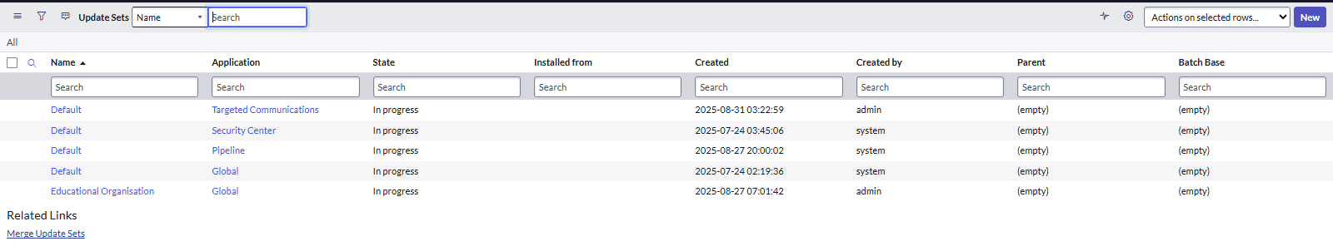

**Milestone 2: Creating a Table**

**Activity 1: Creating Salesforce Table.**

**Steps:**

1. Navigate to **All → Tables**.
2. Click on **New**.
3. Enter the table details:

* **Label**: Salesforce(API Name will be auto-generated).

1. Add the following fields/columns to the table:

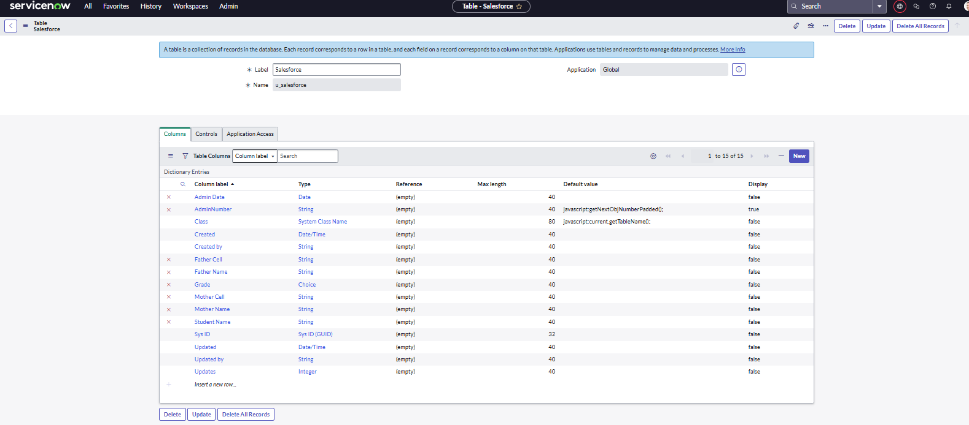

1. **For** **Admin Number**:
   1. Open the field, go to **Advanced View → Default View**.
   2. Enable **Use dynamic default**.
   3. Select **Get Next Padded Number** in Dynamic Default Value.
   4. Update the field.

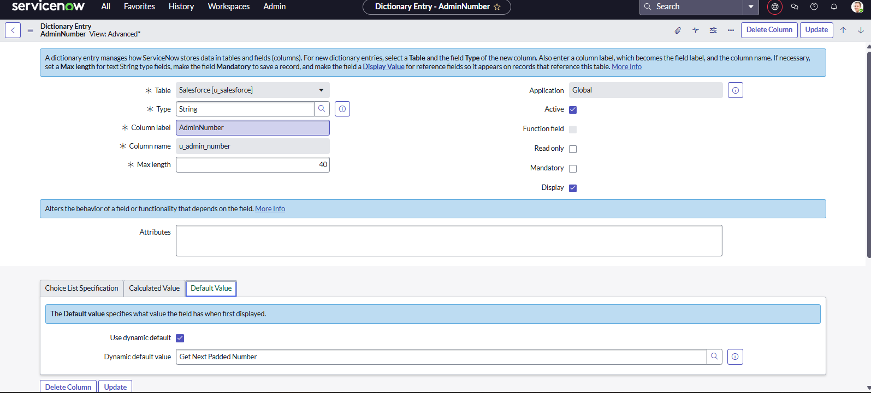

1. **For** **Grade**:
   1. Open the field, go to **Choices**.
   2. Define **Label, Value, and Sequence** for grade options.

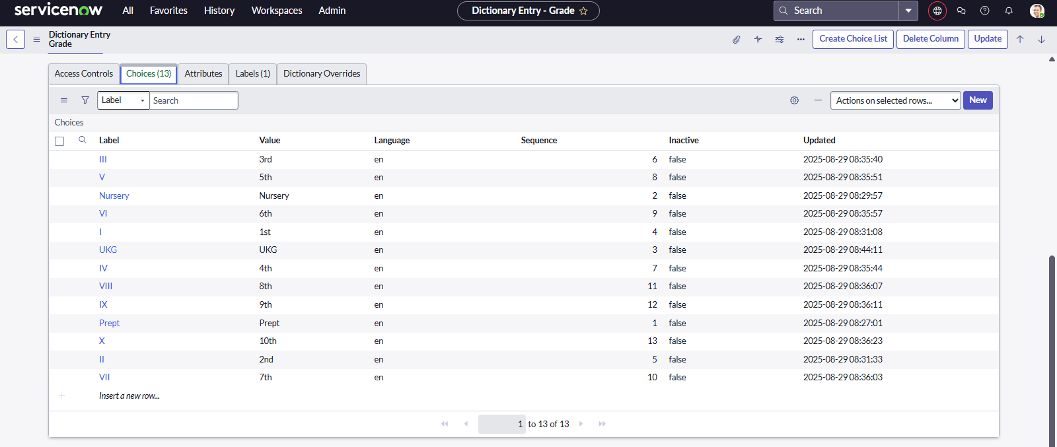

### Activity 2: Creating Admission Table

**Steps:**

1. Navigate to **All → Tables**.
2. Click on **New**.
3. Enter the table details:

* **Label**: Admission
* **Extends Table**: SalesForce(to inherit existing student details).
* **Add Module to Menu**:SalesForce (to make the table accessible in the application menu).

1. Add the required fields/columns for admission details.

### 

1. **For Admin Status**: Create a **choice field** with predefined values to represent different admission statuses (e.g., Pending, Approved, Rejected).

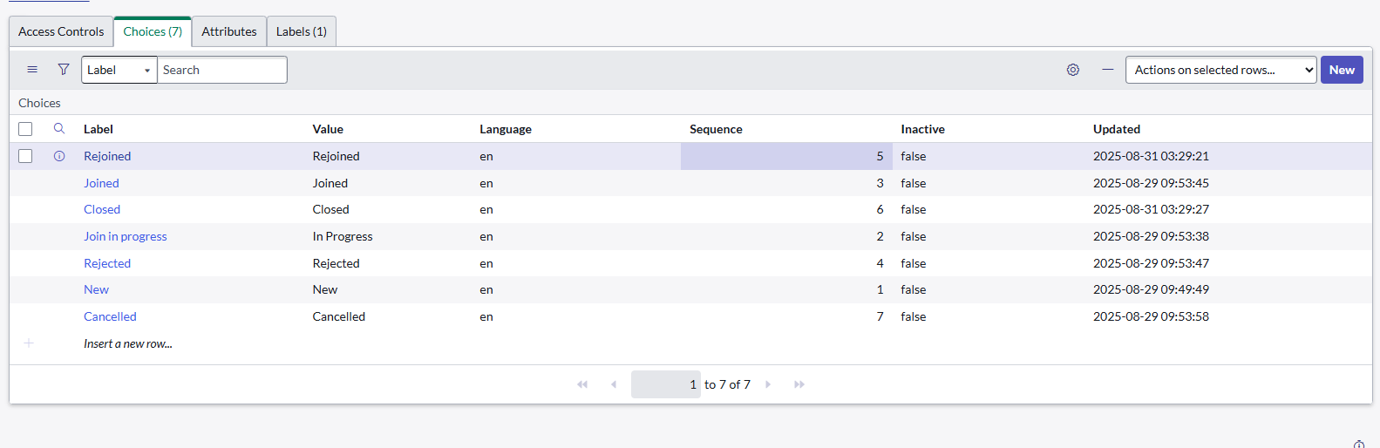

1. **For Pincode**: Create a **choice field** with valid pincode options to standardize address entry.

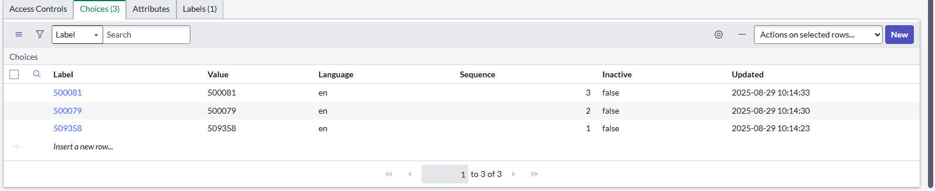

1. **For Purpose of Join**:

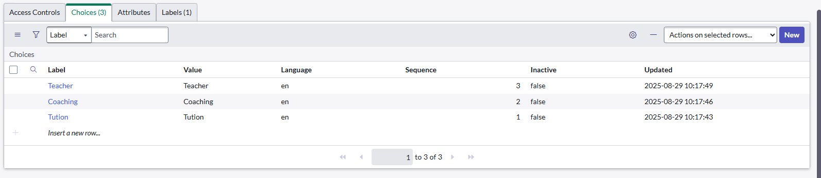

1. **For School**: Create a **choice field** with a list of schools to select from.

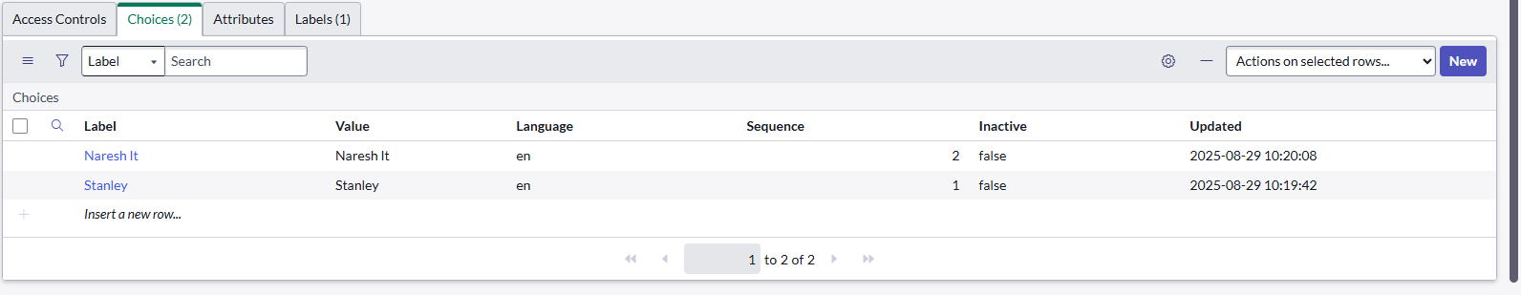

1. **For School Area**: Create a **choice field** with area names for accurate mapping of school locations.

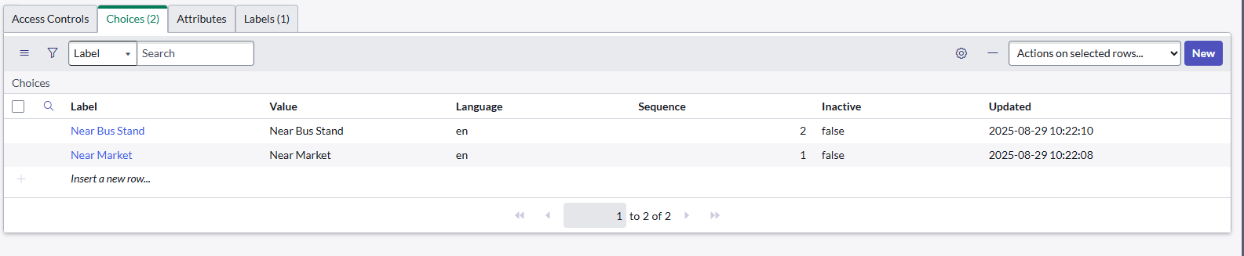

### Activity 3: Creating Student Progress Table

**Steps:**

1. Navigate to **All → Tables**.
2. Click on **New**.
3. Enter the table details:

* **Label**: Student

1. **Add Module to Menu**:Salesforce(so the table appears in the Salesforce application menu).
2. Add the required fields/columns to track student progress.

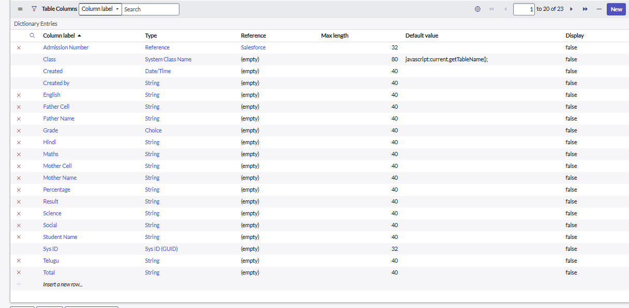

### Milestone 3: Form Layout

### Activity 1: Configuring Table form for Student Progress Table

**Steps:**

* Open the **Student Progress Table**.
* Click on **Layout Form** to configure the table form view.
* From the **Available Fields** list, locate **Admission Number [+]**.
* Expand the field and select the required sub-fields of **Admission Number**.
* Move the selected fields to the **Selected Fields** side.
* Click **Save** to update the form layout

## 

### Milestone 4: Form Design

### Activity 1: Creating Form Design for Salesforce Table

**Steps:**

1. Navigate to **All → System Definition → Tables**.
2. Search for the table **Salesforce** and open it.
3. Right-click on the top header (toggle) and select **Configure → Form Design**.
4. In the dropdown menu, choose **Salesforce(u_salesforce)**.
5. Drag and drop the required fields into the form layout on the left side.
6. Click **Save** to apply the changes.

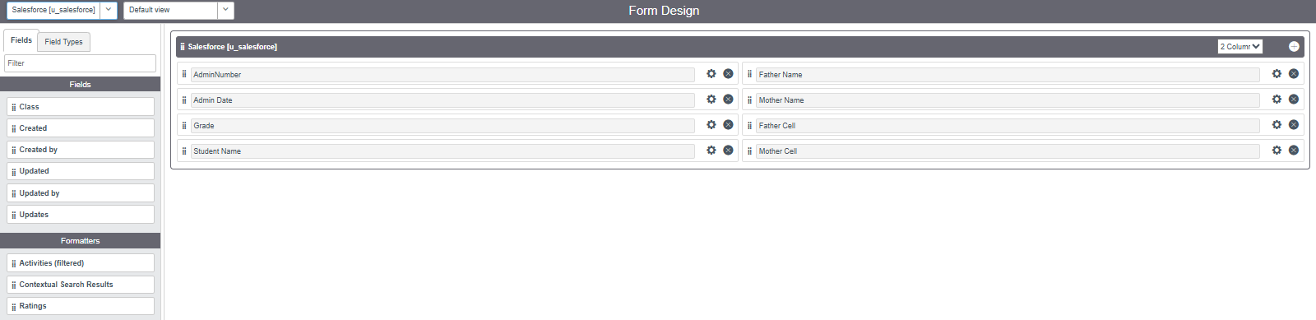

### Activity 2: Creating Form Design for Admission Table

**Step:**

1. Navigate to **All → System Definition → Tables**.
2. Search for the table **Admission** and open it.
3. Right-click on the top header (toggle) and select **Configure → Form Design**.
4. In the dropdown menu, choose Admission(u_admission)
5. Drag and drop the required fields into the form layout on the left side.
6. Click **Save** to apply the changes.

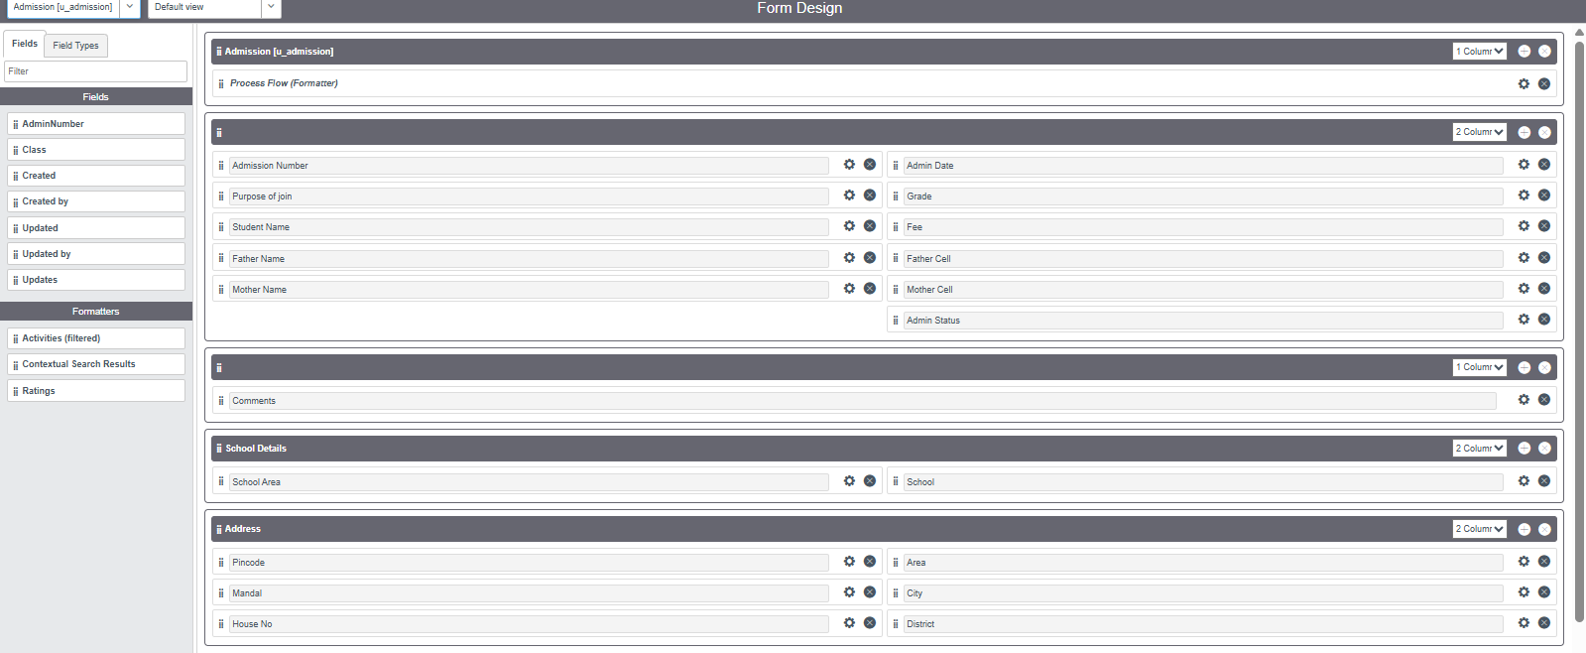

### Activity 3: Creating Form Design for Student progress Table

**Step:**

1. Navigate to **All → System Definition → Tables**.
2. Search for the table **Students** and open it.
3. Right-click on the top header (toggle) and select **Configure → Form Design**.
4. In the dropdown menu, choose Students(u_students)
5. Drag and drop the required fields into the form layout on the left side.
6. Click **Save** to apply the changes.

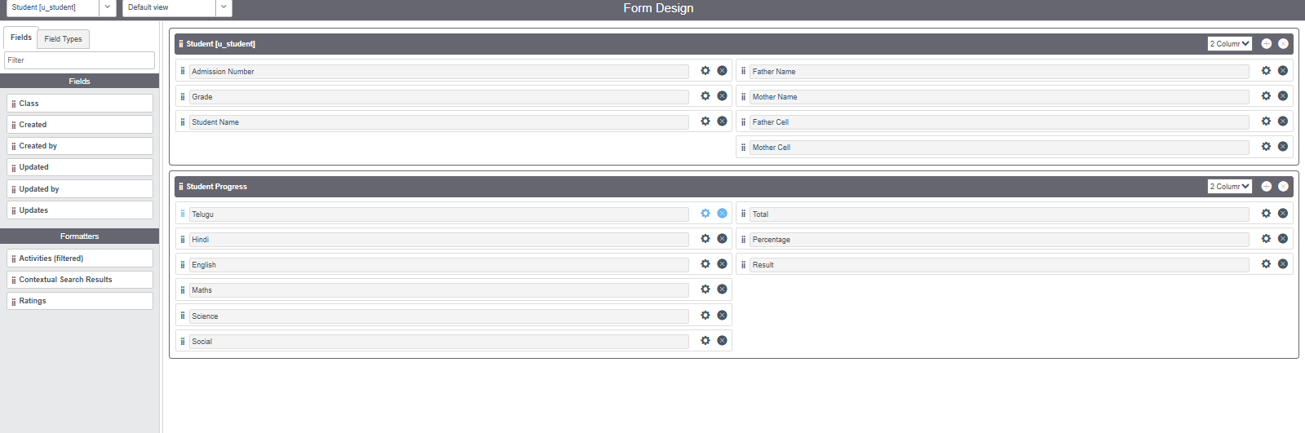

### Milestone 5: Number Maintenance

### Activity 1: Creating Number Maintenance for Admin Number

**Steps:**

1. Navigate to **All → Number Maintenance → New**.
2. Fill in the required details for the **Admin Number** configuration.
3. Click **Submit** to save the record.

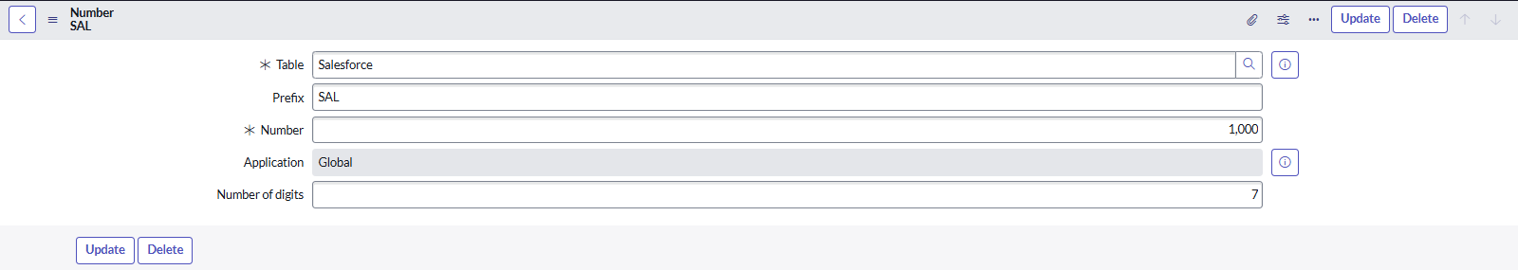

### Milestone 6: Process Flow

### Activity 1: Creating Process Flow for Admission Table

**Steps:**

1. Navigate to **All → Process Flow → New**.
2. Fill in the required details for the admission process flow.
3. Right-click on the header (toggle) and click **Save**.
4. Replace the **Name** and **Label** fields as needed, then click **Insert and Stay**.
5. Continue updating the **Name** and **Label** for each process stage, clicking **Insert and Stay** after each step.

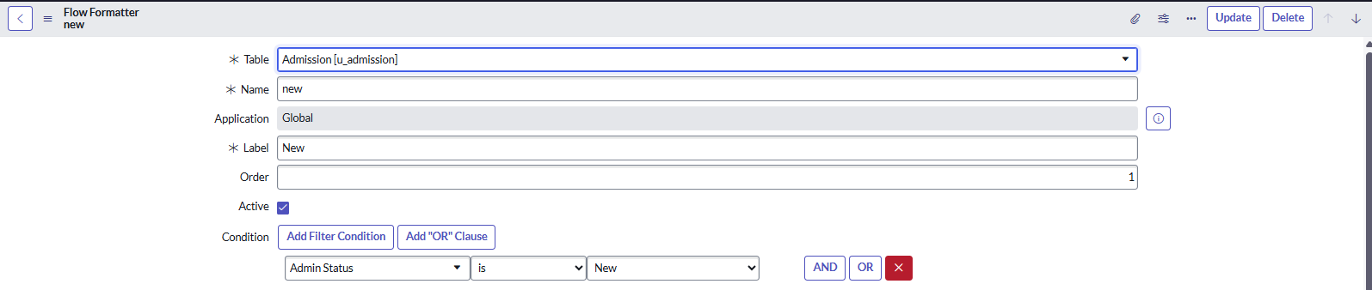

### 

### 

### Milestone 7: Client Script

### Activity 1: **Auto Populate Script** – Admission Table.

**Steps:**

1. Navigate to **All → Client Scripts → New**.
2. Fill in the required details, such as **Name, Table, UI Type, and Script**.
3. Click **Submit** to save the client script.

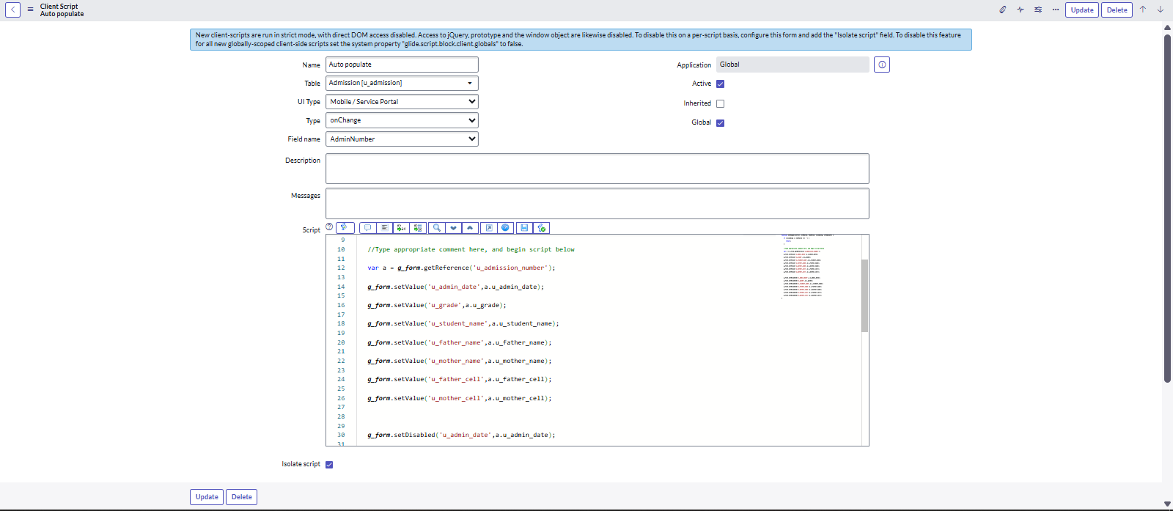

### Activity 2: **Pincode Update Script** – Admission Table.

**Steps:**

1. Navigate to **All → Client Scripts → New**.
2. Fill in the required details, such as **Name, Table, UI Type, and Script**.
3. Click **Submit** to save the client script.

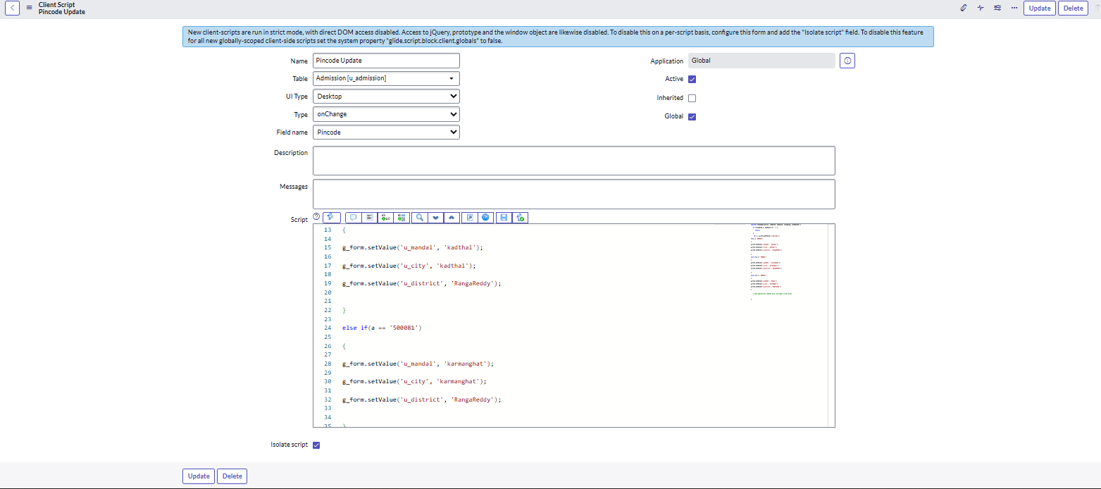

### Activity 3: **Disable Fields Script** – Student Progress Table.

**Steps:**

1. Navigate to **All → Client Scripts → New**.
2. Fill in the required details, such as **Name, Table, UI Type, and Script**.
3. Click **Submit** to save the client script.

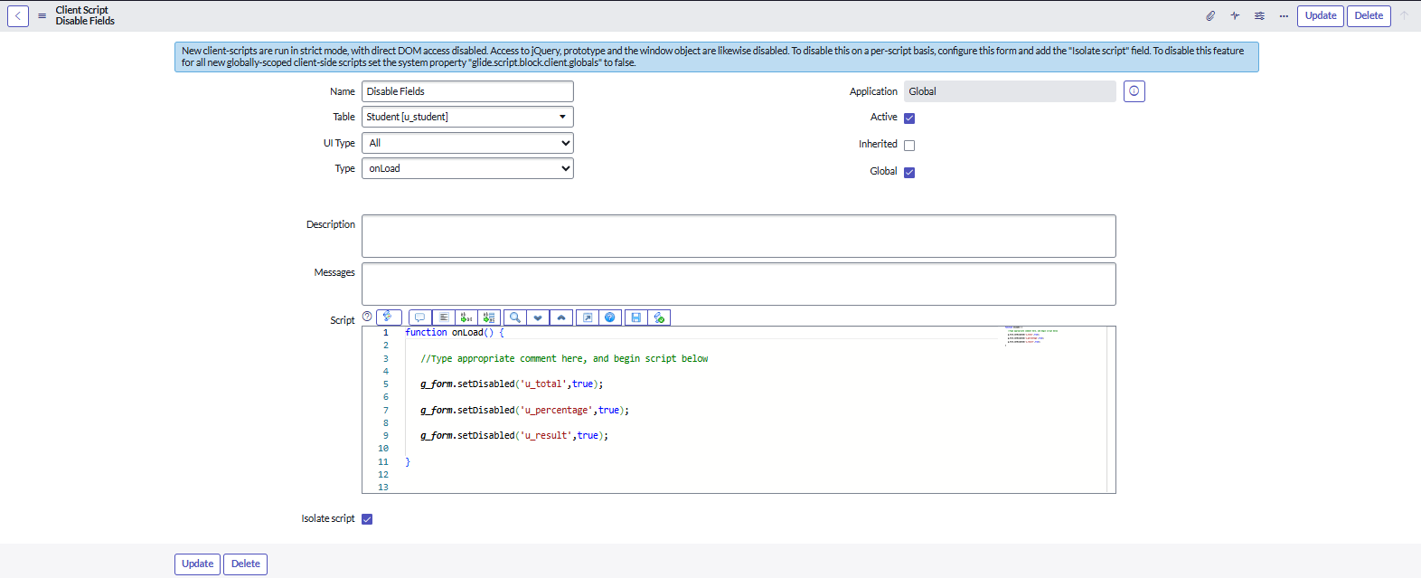

### Activity 4: **Total Update Script** – Student Progress Table.

**Steps:**

1. Navigate to **All → Client Scripts → New**.
2. Fill in the required details, such as **Name, Table, UI Type, and Script**.
3. Click **Submit** to save the client script.

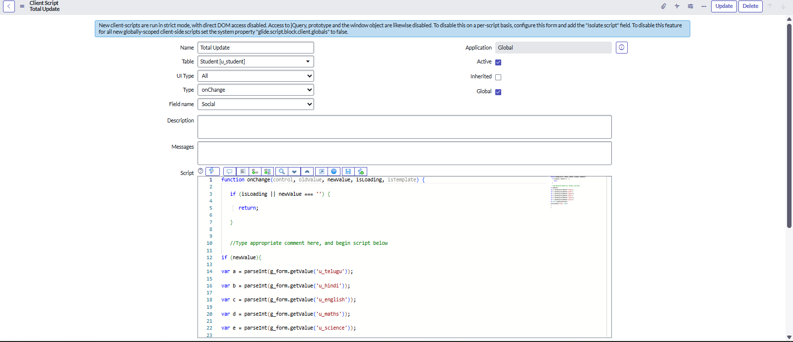

### Activity 5: **Result Script** – Student Progress Table.

**Steps:**

1. Navigate to **All → Client Scripts → New**.
2. Fill in the required details, such as **Name, Table, UI Type, and Script**.
3. Click **Submit** to save the client script.

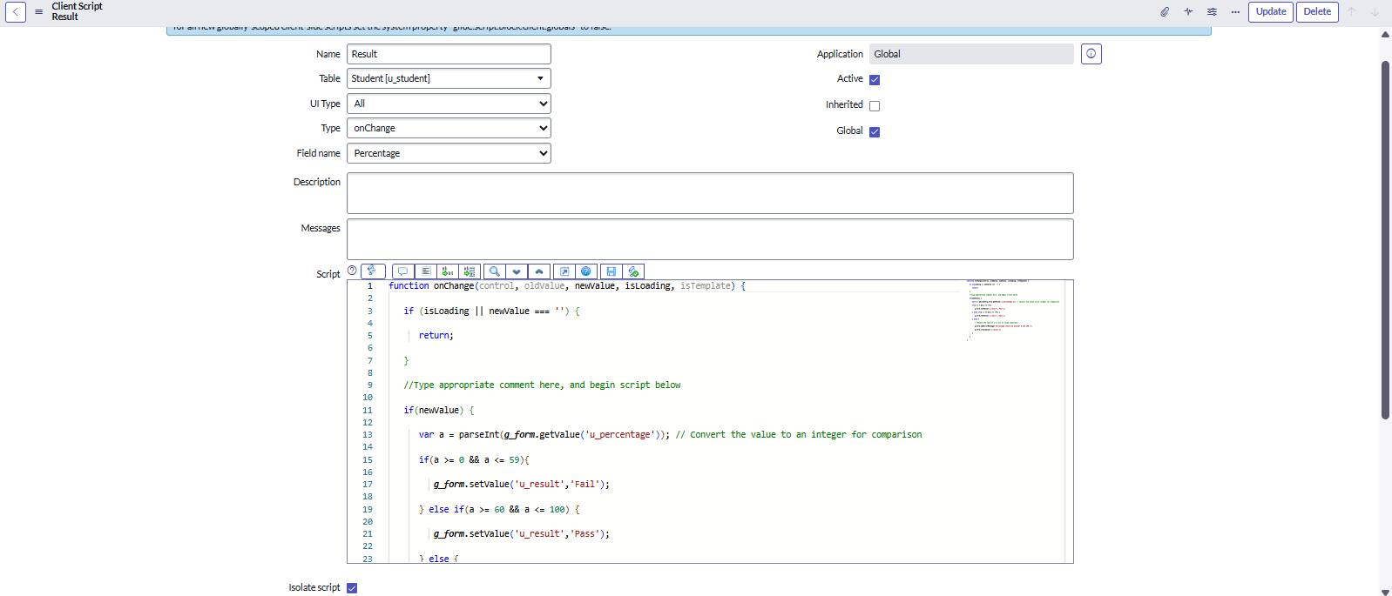

### Activity 6: **Percentage Script** – Student Progress Table.

**Steps:**

1. Navigate to **All → Client Scripts → New**.
2. Fill in the required details, such as **Name, Table, UI Type, and Script**.
3. Click **Submit** to save the client script.

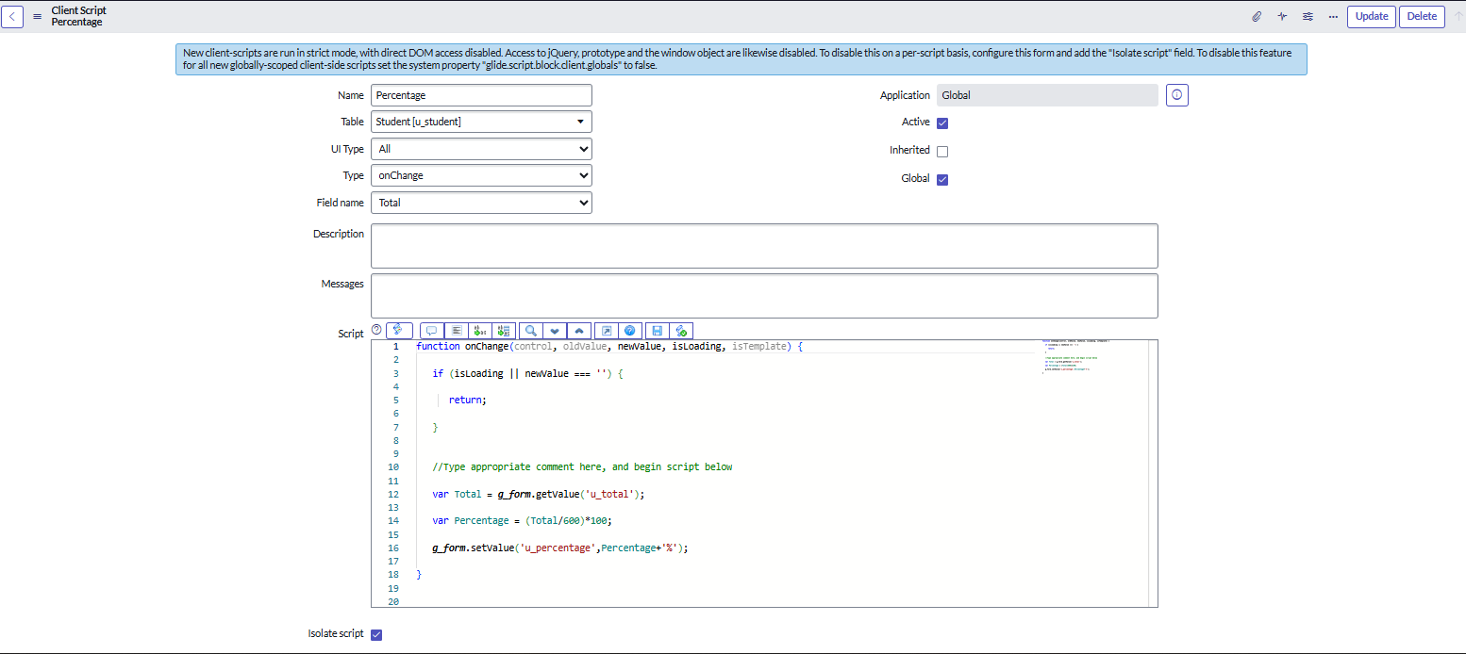

### Result

1. **Salesforce Table created.**

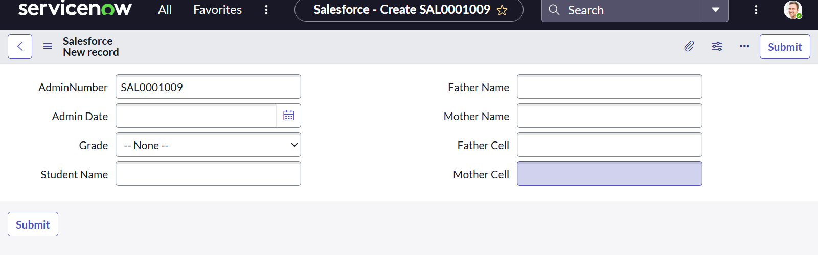

1. **Admission Table created.**

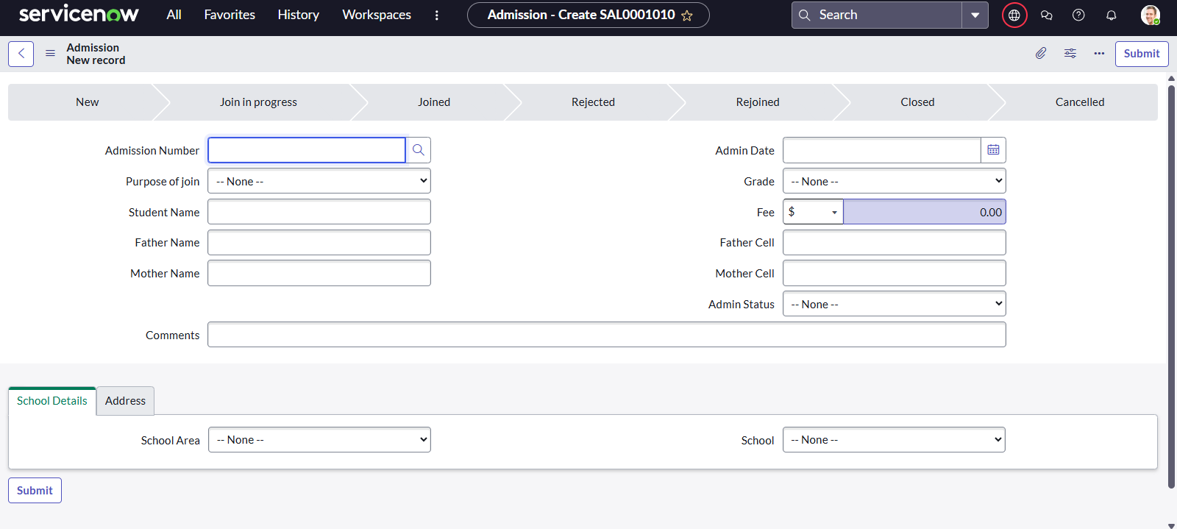

1. **Student Progress Table created**

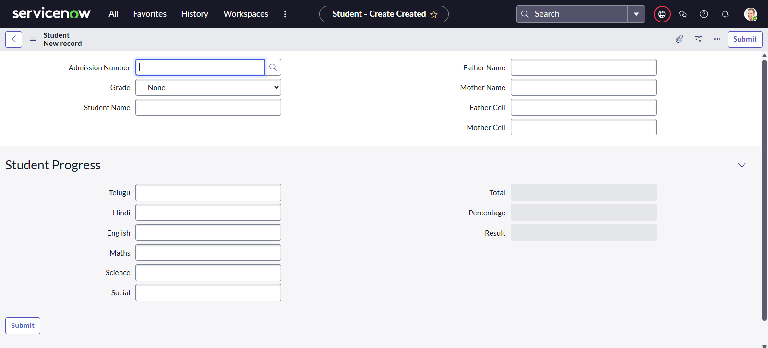

**Conclusion**

The project **“Educational Organisation Using ServiceNow”** successfully automated the management of student admissions and records. By using custom tables, forms, workflows, and client scripts, the system improved efficiency, reduced manual work, and provided a structured way to handle educational data